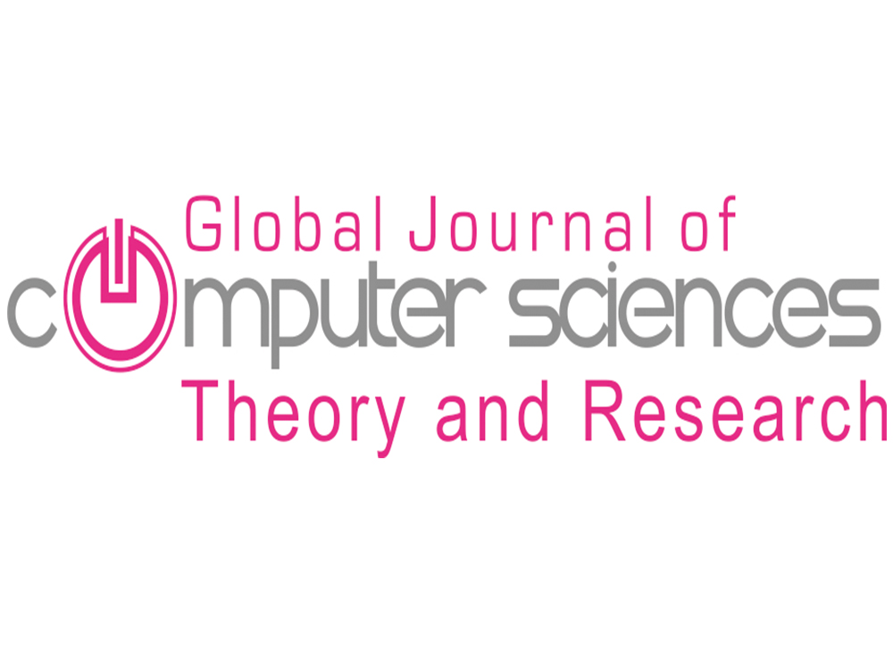

Global Journal of Computer Sciences: Theory and Research
Copyright Agreement Form

Please complete and sign the form and send it with the final version of your manuscript. The completed form is required to obtain written confirmation from authors in order to acquire copyrights for papers published in the journal.

Title of paper: ________________________________________________________________________

________________________________________________________________________

________________________________________________________________________

Author(s): ________________________________________________________________________

________________________________________________________________________

________________________________________________________________________
The undersigned hereby transfers any and all rights to the paper, including without limitation all copyrights, to Global Journal of Computer Sciences: Theory and Research (GJCS), The undersigned hereby represents and warrants that the paper is original and that he/she is the author of the paper, except for material that is clearly identified along with its original source and permission notices from the copyright owners where required. The undersigned represents that he/she has the power and authority to make and execute this declaration.

This agreement is to be signed by at least one of the authors who has obtained the assent of the co-author(s) where applicable.

________________________________________________________________
Author's Signature & Date

________________________________________________________________
Typed or Printed Name

________________________________________________________________
Institution or Company

