(For Discussion papers)
Type the title of your paper

First Author ª, First affiliation, Address, City and Postcode, Country, orcid, email. (In the submission phase, please leave blank. Do not write any information)
Second Author ^{b}, Second affiliation, Address, City and Postcode, Country, orcid, email. (In the submission phase, Please leave blank. Do not write any information)
Third Author ^{c}, Third affiliation, Address, City and Postcode, Country, orcid, email. (In the submission phase, Please leave blank. Do not write any information)
(MAXIMUM SIX AUTHORS)

Received from; revised from; accepted from. (In the submission phase, Please leave blank. Do not write any information)

Selection and peer review under the responsibility of ……………………………..

©2025 by the authors. Licensee TAEG-CENTER. This article is an open access article distributed under the terms and conditions of the Creative Commons Attribution (CC BY) license https://creativecommons.org/licenses/by/4.0/).

IThenticate Similarity Rate:

Abstract

The abstract of the work should be a single paragraph between 150-200 words. Abstracts for research articles should provide an appropriate overview of the study. Briefly, without a title for a well-structured abstract: Background of the Study (Clearly state what the problem is and the purpose of the study); Method (slightly mention the methods and techniques used in the study); Results: (main findings from research); Conclusion: indicate the main conclusions and comments. (These elements may need some adaptation in the case of discussion papers: Background, Purpose of Study, Sources of Evidence, Main Argument, and Conclusions). Do not write place or university name in the title and abstract. You can write in the method without repeating it in the relevant places. Do not use any statistical sign or number. In addition, no citation, abbreviations, and reference. The abstract should not contain results not presented or proven in the article. Please submit your manuscript blind to the conference system from in a Microsoft Word format. For further information, please get in touch with us at taegcenter@gmail.com

Keywords: First keyword, second keyword, third keyword, fourth keyword; (Select five to seven keywords that are pertinent to the topic yet are also widely used in the field.)

- INTRODUCTION (MAJOR THEME)
Here introduces the paper, and put a conceptional framework, if necessary, in a box with the same font size as the rest of the article. The paragraphs continue from here and are only separated by headings, subheadings, images and formulae. Numbers, bold and 10 pt, arrange the section headings.
The introduction should put the research topic in broad context and explain why it is important. Existing literature on the research topic should be reviewed, and references should be made to articles reflecting the importance of the topic.
References should be shown in parentheses following APA 7 standards. See the end of the document for examples of references. When using APA format, follow the author-date method of in-text citation. This means that the author's last name and the year of publication for the source should appear in the text, like, for example, (Jones, 1998). One complete reference for each source should appear in the reference list at the end of the paper.
At the end of the Introduction section, research needs (gaps), and the purpose of the article, related to the subject under study should be expressed with justifications.
METHOD AND MATERIALS
Under this heading, where and how the data were collected and how they were interpreted should be explained. Data can be collected from libraries, online databases, sources in special libraries, newspaper archives, state and school archives, and similar institutions.
RESULTS
In this section;
logical development of the theme,
author's point of view,
implications,
please explain.
Tables, graphs and images related to the results will be embedded in the text and explained in accordance with APA 7 Style.
Tables
All tables should be numbered with Arabic numerals. Headings should be placed above tables and left justified. Leave one line space between the header and the table. Only horizontal lines should be used within a table to distinguish the column headings from the body and immediately above and below the table. Tables must be embedded into the text and not supplied separately. Table contents should be typed in font size 10.

Table 4
Results of N-Gain Experiment and Control
Class | Test | Total | Mean | Variance | St. dev.
Experiment | Pre-test | 4,255 | 56.11 | 169.88 | 13.03
 | Post-test | 5,238
Control | Pre-test | 4,289 | 30.59 | 148.47 | 12.18
 | Post-test | 4,820

Figures
Figures include all graphical displays of information that are not tables. Common types include graphs, charts, drawings, maps, plots, and photos. Just like tables, figures should supplement the text and should be both understandable on their own and referenced fully in the text. This section details elements of formatting writers must use when including a figure in an APA document, gives an example of a figure formatted in APA 7 style. Table contents should be typed in font size 10.
Figure 1
Framing Scores for Different Reward Sizes
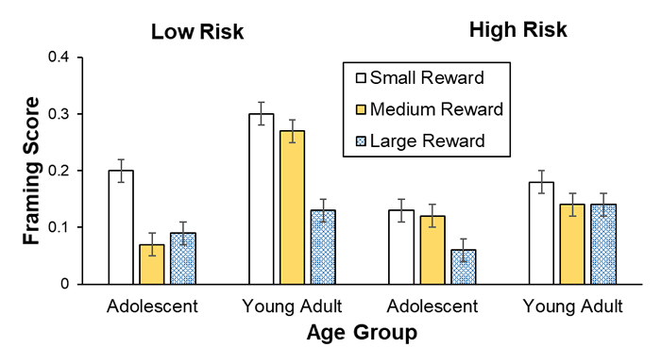
4. INFERENCES, OR CONCLUSIONS.
In this section, the scientific result obtained should be written clearly. This section does not have to be separate from the discussion. However, if the discussion part is long or complex, the conclusion part can be written separately. In this section, the limitations of the study can also be mentioned.
Acknowledgments (when appropriate): Collate acknowledgments in a separate section at the end of the article before the references and do not, therefore, include them on the title page, as a footnote to the title, or otherwise. List here those individuals who provided help during the research (e.g., language editing, writing assistance, fieldwork, etc.) and sponsors.

Author Contributions: For research articles with several authors, a short paragraph specifying their individual contributions must be provided.
Funding: Please add: “This research received no external funding” or “This research was funded by NAME OF FUNDER, grant number XXX”

REFERENCES
The references should correspond to the APA 7 Style formatting (see Appendix) in alphabetical order. The list of references should contain at least 15 and no more than 40 sources, of which more than 50% are sources for the last 3-5 years, including at least 10 sources from the Scopus database (at least 70 percentile) and Web of Science (at least 1 and 2 quartiles - Q1-Q2).
You can reach APA 7 standard from the following link:
https://owl.purdue.edu/owl/research_and_citation/apa_style/index.html
For Examples.

Article
Baniya, S., & Weech, S. (2019). Data and experience design: Negotiating community-oriented digital research with service-learning. Purdue Journal of Service-Learning and International Engagement, 6(1), 11–16. https://doi.org/10.5703/1288284316979

Book
Stoneman, R. (2008). Alexander the Great: A life in legend. Yale University Press.

Translation
Plato (1989). Symposium (A. Nehamas & P. Woodruff, Trans.). Hackett Publishing Company. (Original work published ca. 385-378 BCE)

Article Or Chapter in an Edited Book
Armstrong, D. (2019). Malory and character. In M. G. Leitch & C. J. Rushton (Eds.), A new companion to Malory (pp. 144-163). D. S. Brewer.

Webpage or Piece of Online Content

Price, D. (2018, March 23). Laziness does not exist. Medium. https://humanparts.medium.com/laziness-does-not-exist-3af27e312d01

Authors Short Bios (optional)

Appendix
The appendix is an optional section that can contain details and data supplemental to the main text—for example, explanations of experimental details that would disrupt the flow of the main text but nonetheless remain crucial to understanding and reproducing the research shown; figures of replicates for experiments of which representative data is shown in the main text can be added here if brief, or as Supplementary data. Mathematical proofs of results not central to the paper can be added as an appendix.
All appendix sections must be cited in the main text. In the appendices, Figures, Tables, etc.
If there is more than one appendix, they should be identified as A, B, etc. Formulae and equations in appendices should be given separate numbering: Eq. (A.1), Eq. (A.2), etc.; in a subsequent appendix, Eq. (B.1), and so on.

* ADDRESS FOR CORRESPONDENCE: Name, Surname, Affiliation, Address, City and Postcode, Country E-mail address: xxx.xxx@xxx.com / Tel.: +0-000-000-0000

