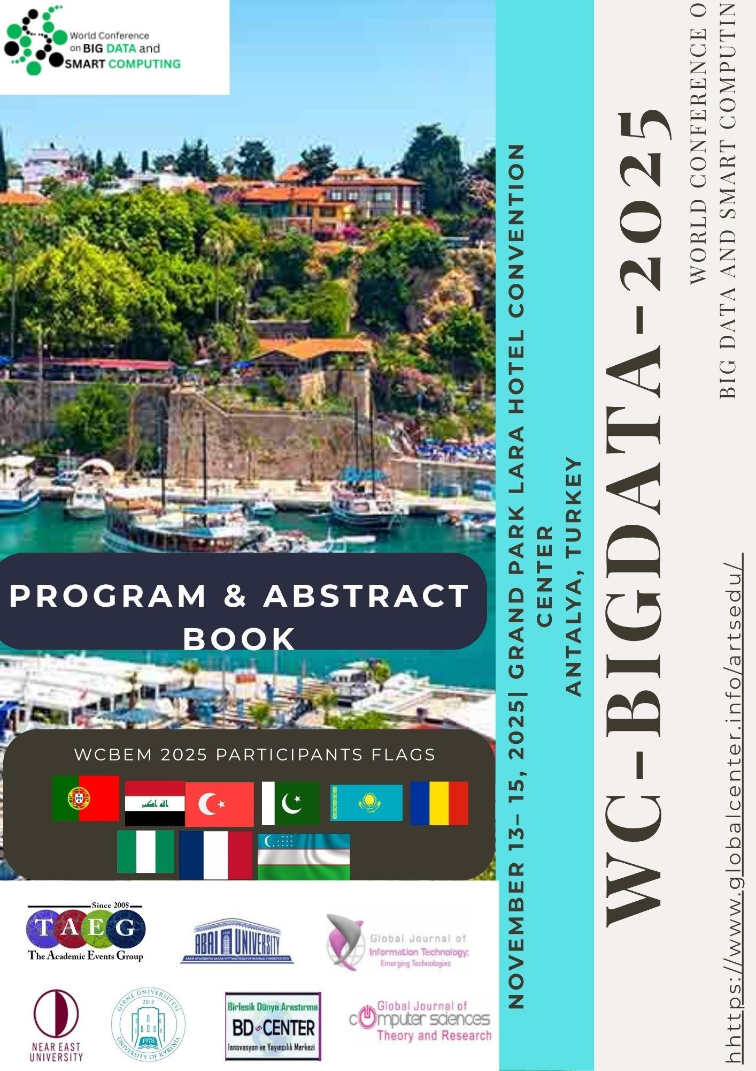
8th World Conference on Big Data and Smart Computing https://www.globalcenter.info/wc-bigdata/
Grand Park Lara Hotel Convention Center

Antalya – Turkey

13 – 15 November 2025

https://meet.google.com/pat-vqbb-vtp

PROGRAM BOOK

Organization

University of Kyrenia

BD-Center, Nicosia, Cyprus
Organized by
The Academic Event Group
Association for Education Science and Technology

Program Chair
Prof. Dr. Doğan Ibrahim, Near East University, Cyprus (Retired)

International Program Committee

Adisa Daberdini, Albanian University, Albania
Aslıhan Tüfekçi, Gazi University, Turkey
B. Turksen, University of Toronto, Canada
Bashkim Ziberi, State University of Tetova, Republic of Macedonia
Ergun Gide, CQUniversity Sydney, Australia
Lejla Abazi, South East European University, Republic of Macedonia
Levent Çetinkaya, Çanakkale Onsekiz Mart University, Turkey
Mehmet Karamanoglu, Middlesex University, UK
Naile Demiri, AAB College, Republic of Kosovo
Valentina Gogovska, Ss. Cyril and Methodius University in Skopje, Republic of Macedonia
Venera Llunji, AAB College, Republic of Kosovo

Organizing Committee

Dr. Tahir Tavukçu, Cyprus Social Sciences University Dr. Nihat Ekizoğlu, Ataturk Teacher Training Academy Blerta Prevalla Etemi, AAB University
Florijeta Hulaj, AAB College
Lilia Trushko, Girne American University
Nesli Bahar Yavaş, European University of Lefke
Semih Çalışkan, Izmir Tınaztepe University
Zeynep Genç, Istanbul Aydın University

Secretariat
Onwudiwe Kenechukwu, University of Kyrenia, Cyprus
wc.bigdata@gmail.com
International Advisory Board

Adem Karahoca, Bahcesehir University, Turkey
Alex James, Indian Institute of Information Technology and Management Kerala, India
Ali Amiria, University of Zanjan, Iran
Ali Hennache, Al-Imam Muhammad Ibn Saud Islamic University, Kingdom of Saudi Arabia Ali Hussain Mohammed, Sri Sai Madhavi Institute of Science & Technology, India AnandNayyar, KCL Institute of Management & Technology, India
Angel Garrido, UNED,Spain
AslihanTufekci, Gazi University, Turkey
Cosmina Ivan, Technical University of Cluj, Romania
Carlo Ghezzi, Italian Academy of Sciences, Italy
David Solomon Raju, Holy Mary Institute of Technology and Science,India
Dennis Gannon, Microsoft, USA
Dogan Ibrahim, Near East University, Cyprus
Eddie YK Ng, Nanyang Technological University, Singapore
Ergun Gide, CQUniversity Sydney, Australia
Fezile Ozdamli, Near East University, Cyprus
Gabriela Grosseck, University of the West Timisoara, Romania Gregorio Hernandez-Zamora, National University of Mexico, Mexico Hafizekeser, Ankara University, Turkey
Han-Chieh Chao, National Ilan University, Taiwan Huseyin Uzunboylu, Near East University, North Cyprus Jacques Bahi, University of Franche-Comte, France
Levent Çetinkaya, Çanakkale Onsekiz Mart University, Turkey
Ling Liu, Georgia Institute of Technology, USA Marathe Dagadu Mitharam, R. C. Patel IMRD, Shirpur Mehmet Erdem, University of Nevada, USA
Mehmet Karamanoglu, Middlesex University, UK
Mohammad Hossein Yarmohammadian, Isfahan University of Medical Sciences, Iran
Mohammad S. Obaidat, Monmouth University, USA Murat Tezer, Near East University, Cyprus
Mustafa Ilkan, Eastern Mediterranean University, Cyprus
OrhanGokcol, Bahcesehir University, Turkey
Ozcan Asilkan, Akdeniz University, Turkey
RamkumarJaganathan, VLB Janakiammal College of Arts and Science, India
Rozhan M. Idrus, University Sains, Malaysia
Sanjay K. Sahay, Department of Computer Science and Information Systems, India
Sevinc Gulsecen, İstanbul University, Turkey
Vijaya Raju, Epoka University, Albania
WibowoSantoso, Central Queensland University, Australia
Yuh-Shyan Chen, National Taipei University, Taiwan
ZulkhairiDahalin, University of Utara, MalaysiaAtılhan Naktiyok, Atatürk University, Turkey
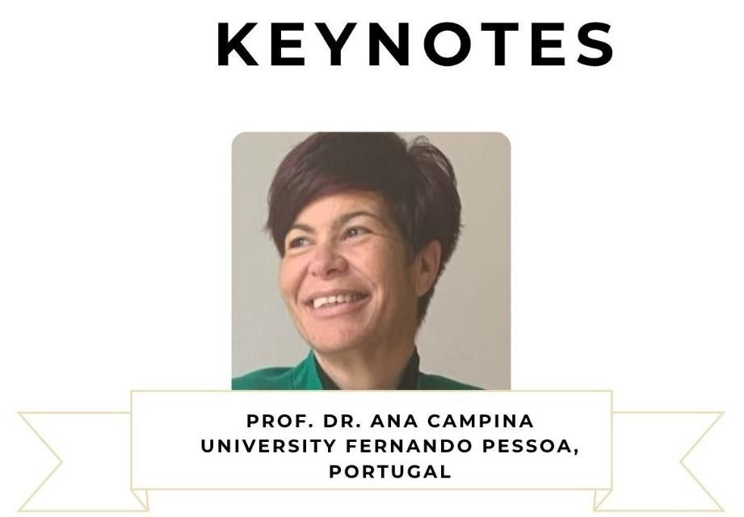

TITLE

The Human Rights Generations and Artificial Intelligence

BIOGRAPGHY

Prof. Dr. Ana Campina has a PhD in Law; PhD in Human Rights; Political Scientist / Expert in International Relations ; FCHS – UFP University Fernando Pessoa Professor; Coordination Postdoctoral Fellowship “Human Rights in the Digital Age” UFP; Coordinator 1st SC Political Science and International Relations UFP; MODULE JEAN MONNET UFP “ “European Union's political statement on Human Rights in the age of Artificial Intelligence” Co-Coordinator; CEPESE
– Centro de Estudos da População, Economia e Sociedade Researcher; FP-I3ID – Instituto de Investigação, Inovação e Desenvolvimento da UFP Researcher; CIGG – Centro de Investigación para la Gobernanza Global Researcher ; OCEAN – Open Council of Europe Academic Networks – Council of Europe Member : COST ACTION Expert; SVTFaculdade Visiting Professor SVTFaculdade (Brazil); Lecturer of Gonçalves Dias Chair (BR); Editor-in-Chief International Journal of New Trends in Social Sciences (IJSS); Editor Board Journal European Journal of Transformation Studies; Editorial Advisory Board of Law ADJURIS – International Academic Publisher; Co-Topic Editor “Human Rights and Artificial Intelligence”.

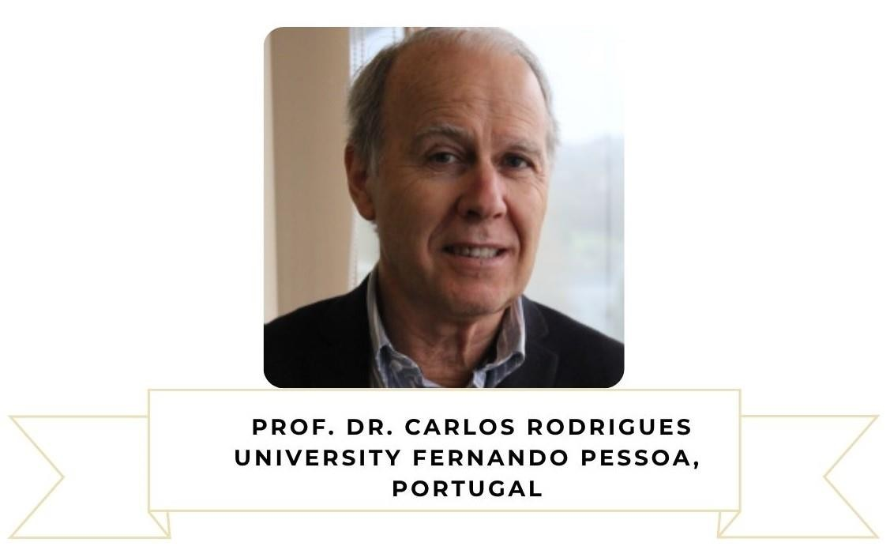

TITLE

The Human Rights Generations and Artificial Intelligence

BIOGRAPHY

Prof. Dr. Carlos Rodrigues has a PhD European Tax Law; Associate Invited Professor in Universidade Fernando Pessoa; University Professor in Law; Coordination Postdoctoral Fellowship “Human Rights in the Digital Age”; MODULE Jean Monnet UFP Coordination; Researcher CEPESE – Centro de Estudos da População, Economia e Sociedade, Researcher FP-I3ID – Instituto de Investigação, Inovação e Desenvolvimento da Universidade Fernando Pessoa; Researcher CIGG – Centro de Investigación para la Gobernanza Global de USAL; SVTFaculdade Visiting Professor SVTFaculdade (Brazil); Lecturer of Gonçalves Dias Chair (BR); Ex-Principal Advisor Tax and Customs Authority; Legal Consultant; Frontiers in Political Science, Co-Topic Editor “Human Rights and Artificial Intelligence”; Editor-in-Chief Global Journal of Sociology: Current Issues (GJSOC); Member do OCEAN-CoE – Open Council of Europe Academic Networks; Member of High Commission of IKSAD Institute; COST – European Cooperation of Science & Technology - External Expert.

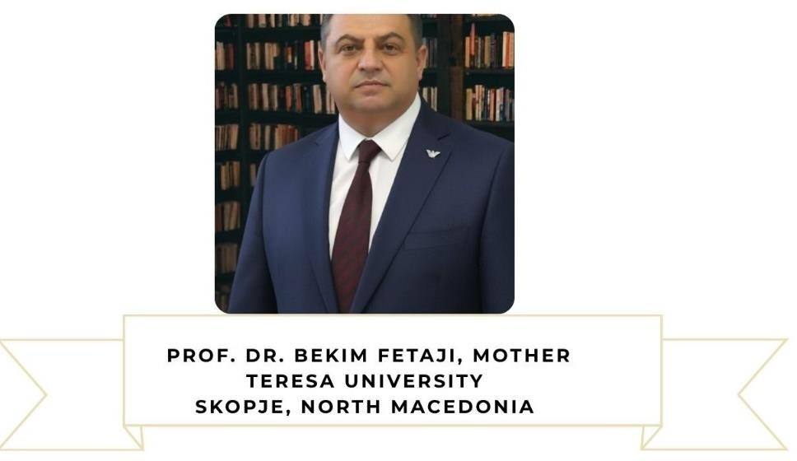

TITLE

Devising Algorithmic Framework for Cybersecurity Scientific Analytics

BIOGRAPHY

Bekim Fetaji is Full Professor of Informatics (Computer Sciences) at University Mother Teresa, Skopje, North Macedonia. I received his PhD in Computer Sciences at the Faculty of Computer Sciences at Graz University of Technology in 2008. He received his master’s degree from Oxford Brookes University, Oxford, England UK. He was Visiting Professor at Staffordshire University UK, Tokyo University of Agriculture and Engineering, Japan, OREBRO University, Computer Science, Sweden, Canadian Institute of Technology, Tirana, Albania, Rochester Institute of Technology RIT, campus Prishtina, Kosovo, University of Novi Pazar, Serbia and other Universities. More than 25 years of teaching experience and working in higher education in different Universities in the region and abroad. Lectured in 4 languages in different Universities: English, Albanian, Macedonian, Serbian language.

Participated in several projects within different programs such as Tempus, Erasmus and other national and international research projects. Published more than 150 scientific papers in international conferences most of them in IEEE and ACM and more than 30 international journals, some of them with ISI Web of Science impact factor. Published 9 (nine) academic textbooks and 2 (two) books in English that can be found online at Amazon. Keynote speaker in many conferences among others also in IEEE Conferences (Reference: https://iccece23.theiaer.org/keynote.html).

Main research interest and published work is in enhanced technology enhanced education, virtual learning environments, software engineering, programming and lately Data science with AI and machine learning, Data processing with Data Analytics and closely related fields.

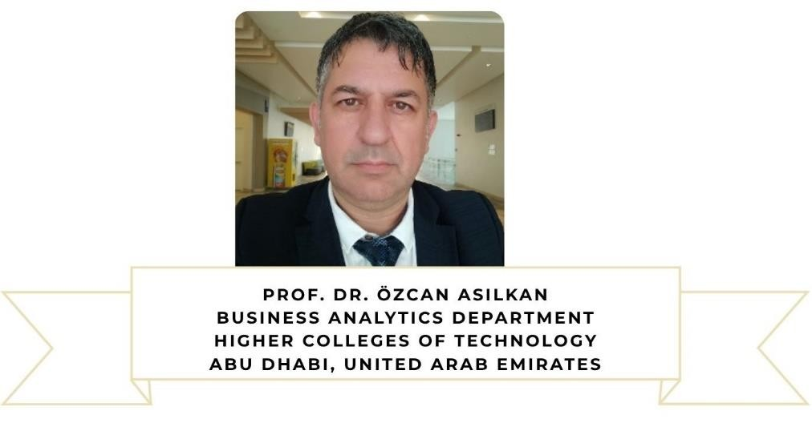

TITLE

AI-Powered Personalized Learning Pathways

BIOGRAPHY
.
Prof. Dr. Özcan Asilkan is an accomplished Computer Science Engineer and Academic with a robust background spanning higher education and multiple industries, including software development, data analysis, manufacturing, tourism, and healthcare. His research interests cover a broad range of interdisciplinary topics such as Management Information Systems (MIS), Business Analytics, Computer Science, Database Systems, Data Mining, Customer Relationship Management (CRM), and Hospitality Management.

With nearly 30 years of combined academic and industry experience, Prof. Asilkan has held numerous teaching and professional engagements across almost 10 countries and 15 universities worldwide.

In academia, he has served in various leadership and instructional capacities; including Dean, Chair, and Lecturer, and has taught a wide array of courses while publishing nearly 70 academic papers. He has also participated as a Chair and Keynote Speaker at more than 10 international conferences.

As a Computer Science Engineer, Prof. Asilkan has undertaken diverse professional roles such as Systems Analyst, Database Administrator, Application Developer, and Consultant, contributing to several major projects, including the implementation of CRM and ERP systems.

Since July 2024, he has been serving at the Higher Colleges of Technology (HCT) in Abu Dhabi, United
Arab Emirates.
PROGRAM
14/11/2025, Friday
ONLINE PRESENTATIONS

14.11.2025  9:00 – 9:20 | Opening Ceremony | Hall 1

TIME | TITLE | SPEAKER | HALL NAME
14.11.2025  9:20 – 10:00  Keynote 1 | “AI-Powered Personalized Learning Pathways” | Prof. Dr. Özcan Asilkan Senior Lecturer  Business Analytics Department  Higher Colleges of Technology  Abu Dhabi, United Arab Emirates | 1

TIME | TITLE | SPEAKER | HALL NAME
14.11.2025  10:00 – 11:00  Keynote 2 | “Devising Algorithmic Framework for Cybersecurity Scientific  Analytics” | Prof. Dr. Bekim Fetaji, Faculty of Informatics, Mother Teresa University, Skopje, North Macedonia | 1

TIME | TITLE | SPEAKER | HALL NAME
14.11.2025  11:00 – 12:00  Keynote 3 | “The Human Rights Generations and the Artificial  Intelligence” | Prof. Dr. Ana Campina, University  Fernando Pessoa, Portugal  Prof. Dr. Carlos Rodrigues, University  Fernando Pessoa, Portugal | 1

12:00 – 13:00 Lunch

Session 1
13:00 – 15:30

ORDER | TITLE |  | AUTHOR, AFFILIATION and COUNTRY
1 |  | A Bibliometric Analysis of Quality in Higher Education | Merve Nur Atalar, Ondokuz Mayis University, Turkey  Aysel Cetindere Filiz, Ondokuz Mayis University, Turkey
2 |  | The Impact of Creative Leadership on Enhancing Municipal Service Efficiency: A Mixed Methods Study | Seror N. Aldouri, University of Samarra, Iraq
3 |  | Demystifying Sustainable Performance in Fmcg Companies: The Roles of Open  Innovation, Dynamic, and Knowledge Management Capabilities | Banji Rildwan Olaleye, North West University,  Potchefstroom, South Africa
4 |  | Exploring the Role of Blockchain Technology in Sustainable Waste Management within Pharmaceutical Supply Chains: An Illustrative Case of the US FDA Project | Khalid Litim, Batna1 University, Batna, Algeria
5 |  | Exploring the Role of Blockchain Technology in Sustainable Waste Management within Pharmaceutical Supply Chains: An Illustrative Case of the US FDA Project | khalid litim, Batna1 University, Batna, Algeria  Houssam Messaoudi, Echahid  Cheikh Larbi Tebessi University, Tebessa,  Algeria  Samir Bensahnoune, Tipaza University, Algeria Nabil Chenene, Echahid Cheikh Larbi Tebessi University, Tebessa , Algeria
6 |  | Understanding management strategies for smart infrastructure in Tomorrow’s  Turkish cities | Hamdi Tekin, Alanya University, Turkey
7 |  | Sensory Metaphors in Digital Tourism Marketing: Bridging the Physical – Digital  Gap | Mihail Cristian Ditoiu, The Faculty of Business and Administration (University of Bucharest), Romania

8 | The Application of Convolutional Neural Network for Classifying Non-Defect from  Defect Software Systems | Aamo Iorliam, Benue State University, Makurdi, Nigeria.
 |  | Özcan Asilkan, Business Analytics Department,
 |  | Higher Colleges of Technology, United Arab
 |  | Emirates.
 |  | Suleiman Adamu, ICT Unit of Sule Lamido
 |  | University in Kafin Hausa, Jigawa State, Nigeria.
 |  | Moses Iorsoo Tyavnande Benue State
 |  | Polytechnic, Ugbokolo, Nigeria.

15/11/2025, Saturday
ONLINE PRESENTATIONS
09:00 – 10: 30
Session 3

ORDER | TITLE |  | AUTHOR, AFFILIATION and COUNTRY
1 |  | Measuring Employer Brand Image and Scale Development for the IT Service  Industry | Anca Clipa, Claudia Stoian, Alexandru Ioan Cuza  University, Romania
2 |  | Influence of Technology Transfer Offices on Commercialisation of Science and  Technology in Latvia | Justīne Vīķe, Rīga Stradiņš University, Latvia
3 |  | The Measurement of Antecedents of Purchase Intentions and WoM Marketing in  Fashion Industry | Mirza Ashfaq Ahmed, University of Gujrat, Pakistan
4 |  | The Impact of Tourism Activity Development on the Romanian Economy | Tiberiu Iancu, Tabita Cornelia Adamov, Sorin Stanciu, Dorin Camen, Mihaela Moatar, Ioan Brad, Romania
5 |  | Trend of Income Inequality In Asia and Effects of Education | Kang Hoon Park, Southeast Missouri State  University, United States

10:30 – 11:00 Coffee Break

Session 4
11:00 – 12:30

ORDER | TITLE |  | AUTHOR, AFFILIATION and COUNTRY
1 |  | Bio-districts as living labs for the promotion of sustainable development and the resilience of territories | Nadia Cipullo, Link Campus University, Italy
2 |  | The impact of European integration on trade flows in Romania | Anca Maria Paraschiv, Laurentiu Dinu, Coralia  Ioana Zavera, Bucharest University of Economic  Studies, Romania
3 |  | Tourism contribution to Gross Domestic Product and Gross Value Added | Ioana Anda MILIN, Iuliana Ioana Merce, Tiberiu  Iancu, Ioan Petroman, Elena Pet, Eugenia Tigan,  Universitity of Agricultural Scienties and  Veterinary Medicine, Romania
4 |  | The challenges of computational simulation with industry 4.0 | Tiago dos Santos Almeida, Lie Yamanaka,  Thales Botelho Souza, Federal University of  Goias, Brasil
5 |  | Research on the tourist traffic in protected areas in Romania | Ioana Anda MILIN, Iuliana Ioana Merce, Cornelia Petroman, Elena Tonea, Universitity of  Agricultural Scienties and Veterinary Medicine,  Romania
6 |  | Transformational leadership style in the relationship between innovation and efficiency of healthcare units | Wojciech Głód, University of Economics, Poland

12:30 – 13:00 Closing Ceremony

16.11.2025
16/11/2025, Sunday
09:00 – 18:00 Antalya Historical Places Tour

